Ex. No. : | 12 | Date : 09/10/2026
Register No. : | 240701629 | Name : Immanuel SA

Approval Process in Zoho Creator

Aim
To build two approval processes in the RentEase application, Repair_Cost_Approval for repairs that cost more than Rs 5,000 and Deposit_Refund_Approval for deposit refunds, so that the owner decides on these before they are carried out.

Introduction

Approvals in Zoho Creator
An approval process lets a record be checked by one or more people before it is accepted. It is defined by a form, a criteria that decides which records need approval, one or more levels of approvers and the actions that follow an approval or a rejection. When a record meets the criteria, it is submitted for approval, the approver is notified, and the record stays pending until the approver approves or rejects it. Every decision is recorded with the record.

Approvals in RentEase
In RentEase the manager runs the rentals, but the owner must approve the larger decisions. The owner approves repair costs above Rs 5,000 and the refund of a tenant's deposit when the tenant moves out. For the demonstration, the admin account acts as the owner and is the approver. The approvals work together with the repair blueprint, where a costly repair waits in the Pending Approval stage, and with the Calculate_Refund workflow, which prepares the refund amount of a move-out request.

Objectives of the Study
- To create an approval process with a criteria, levels and approvers.
- To make repair costs above Rs 5,000 need approval at two levels.
- To send a deposit refund of a move-out request for approval.
- To approve a record as an approver and check the result in Access mode.

Procedure
- Open the RentEase application in Edit mode and click Workflow in the top bar, then open Approvals.
- Create the approval process Repair_Cost_Approval on the form Repair_Approval.
- Set the criteria so that the approval applies when Quoted_Amount is greater than 5000.
- Add two levels of approval and select the approver of each level, who is the admin user acting as the owner.
- Save the approval process.
- Create the approval process Deposit_Refund_Approval on the form Move_Out_Request, select its approver and save it.
- Open the application in Access mode and add a Repair_Approval record with a Quoted_Amount above 5000. Check that it is submitted for approval.
- Open the Approvals section as the approver, review the record and approve it at each level.
1

Dept. of Computer Science and Engineering | Rajalakshmi Engineering College

- Open the record again and check its approval status.
- Take a screenshot of the settings and of each result.

Detailed Analysis of the Approvals
Table 1 lists the two approval processes of RentEase.

Approval process | Form | Applies when | Levels and approver | Purpose
Repair_Cost_Approval | Repair_Approval | Quoted_Amount > 5000 | Two levels; the approver is the admin user acting as owner | Approve costly repairs
Deposit_Refund_Approval | Move_Out_Request | A move-out request with a deposit refund | The approver is the admin user acting as owner | Approve the deposit refund
Table 1: Approval processes in RentEase
Table 2 shows how a repair record moves through the two levels of Repair_Cost_Approval.

Level | Approver | If approved | If rejected
Level 1 | Admin user (owner) | The record goes to Level 2 | The record is rejected and the process stops
Level 2 | Admin user (owner) | The record is approved and the repair can be completed | The record is rejected and the process stops
Table 2: Levels of Repair_Cost_Approval
Table 3 explains the parts of an approval process and how each is used in RentEase.

Part | Meaning | Use in RentEase
Criteria | Decides which records are sent for approval | Quoted_Amount > 5000 for repairs
Level | A step in the approval chain | Two levels for repairs
Approver | The user who approves or rejects the record | Admin user acting as owner
Approval status | The state of the record in the process: Pending, Approved or Rejected | Shown on the Repair_Approval and Move_Out_Request records
Table 3: Parts of an approval process
A repair with a Quoted_Amount of Rs 5,000 or less does not meet the criteria, so it is not sent for approval and the manager can complete it directly. This is the same limit that the Maintenance_Lifecycle_Blueprint uses to choose between Complete and Send for Approval.

2 Dept. of Computer Science and Engineering | Rajalakshmi Engineering College

Output
3
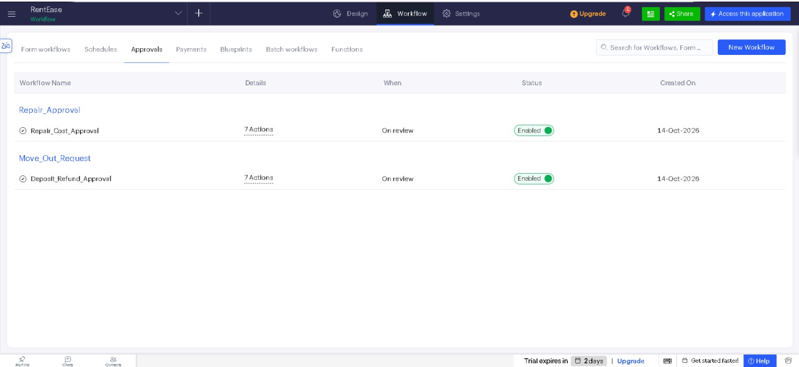
Figure 1: Approval processes of RentEase
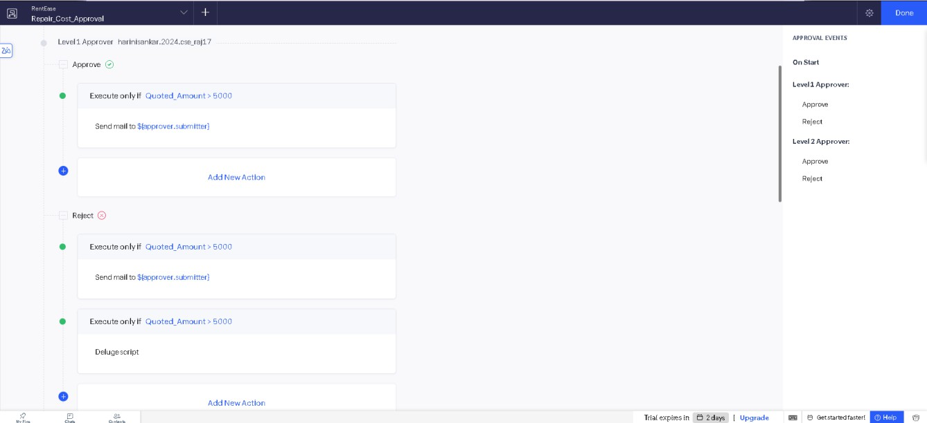
Figure 2: Levels and approver of Repair_Cost_Approval

Dept. of Computer Science and Engineering | Rajalakshmi Engineering College

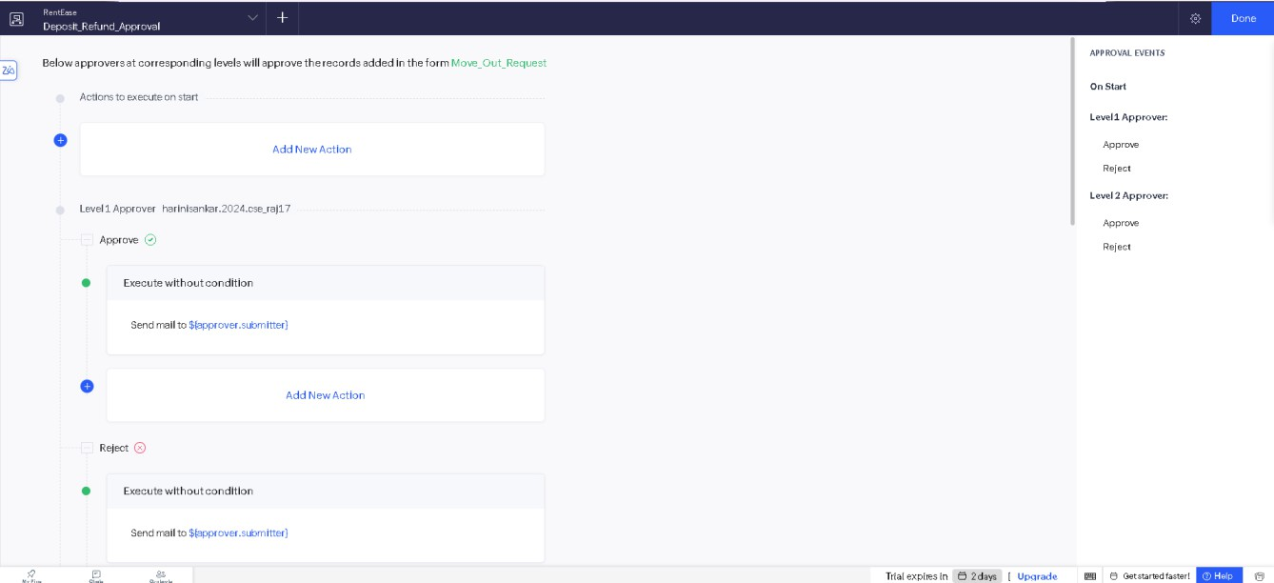
4
Figure 3: Deposit_Refund_Approval on the Move_Out_Request form
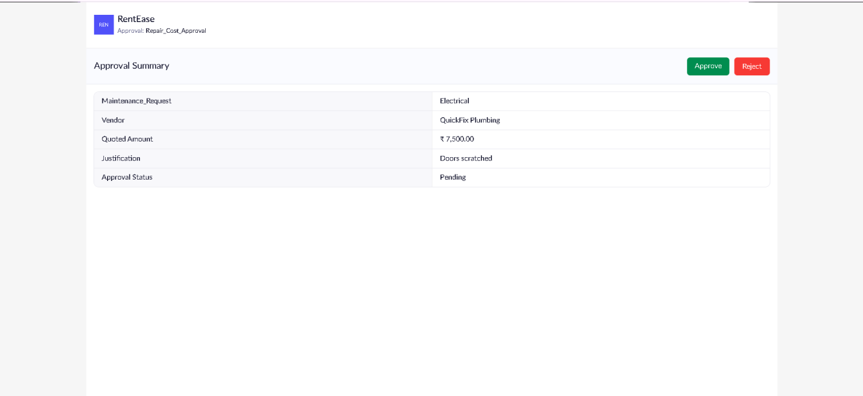
Figure 4: Approval Summary page with Approve and Reject buttons for a Rs 7,500 repair

Dept. of Computer Science and Engineering | Rajalakshmi Engineering College

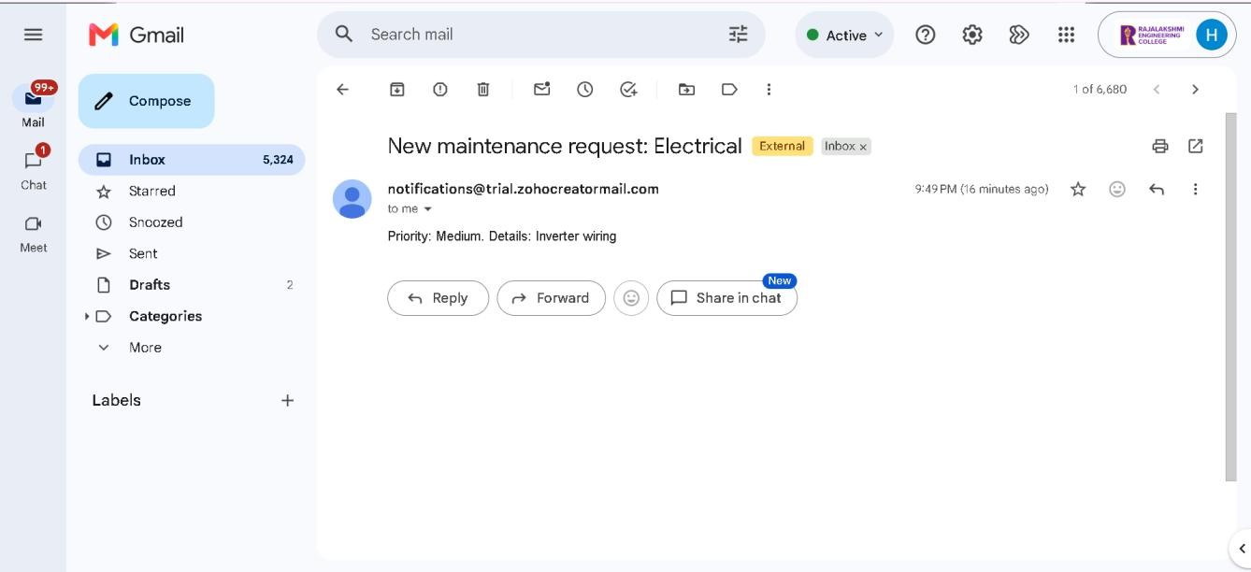
5
Figure 5: Email notification received when a new maintenance request is raised
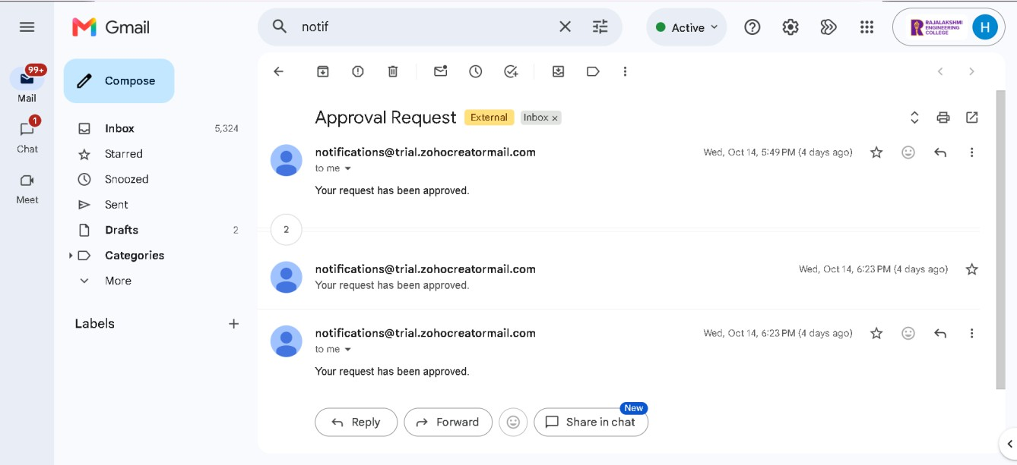
Figure 6: Approval Request emails confirming that the requests were approved

Dept. of Computer Science and Engineering | Rajalakshmi Engineering College

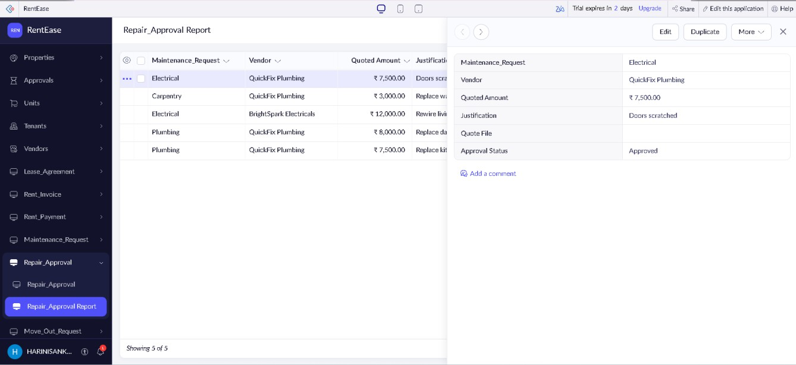
Figure 7: Repair_Approval record with Approval Status changed to Approved

Result
The approval processes Repair_Cost_Approval and Deposit_Refund_Approval were created in RentEase and tested in Access mode. A repair with a Quoted_Amount above Rs 5,000 is sent for approval at two levels, and a deposit refund of a move-out request is sent to the approver, who is the admin user acting as the owner. Repairs and refunds that need the owner's decision are therefore checked before they are carried out.
6

Dept. of Computer Science and Engineering | Rajalakshmi Engineering College

